
Methods 11 Test 3 2018
Relations and Set Notation
Total Marks: 56 Time Allowed: 60 minutes

Name: _______________________

Resource Free

ALL working must be shown for full marks.

1. (1, 1 = 2 marks)

Shade the area indicated

a) 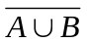 b) 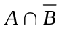
A
B

A
B

2. (2 marks)

Use set notation to describe the shaded region represented in the Venn diagram below:

Q
P

R

3. (4, 6 = 10 marks)

Sets A and B are such that n(A) = 17, n(B) = 26 and n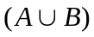= 34. If n(U) = 39:

- Construct a Venn Diagram to represent these sets

- Determine:

i n(A|B)

ii n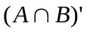

iii n (B|A’)

iv n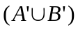

v n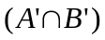

vi n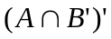

4. [2, 2, 2 = 6 marks]

Find the equations of the circles determined by the following conditions (use form x² + y² = a²)

a) centre (0, 0), radius 5

b) centre (0, 0),

c) centre (-4, -3), radius

5. (3, 1, 1, 1, 1 = 7 marks)

Two hundred people were asked the question, ‘Which overseas destination have you visited” and their responses were as follows:

Seventy nine said they had visited New Zealand and 95 had visited Malaysia. Two had visited all three places, sixteen had visited New Zealand and Europe, and 7 had visited New Zealand and Malaysia and. Seventy three had only visited Malaysia and 31 people said they had visited Europe.

- Draw a Venn Diagram to show the above.

- For how many people was Europe their only overseas destination?

- How many people had visited Europe and Malaysia?

- How many people had visited none of these places?

- How many people had visited exactly two of these places?

6. [3 marks]

The points (-2, 5), (3, k) and (5, 12) are collinear. Find the value(s) of k.

7. [3 marks]

Which of the following are NOT circles? Circle your choice.

a) x² + y² - 4x + 2y = 8 Circle / Not circle

b) x² + y² = 9 Circle / Not circle

c) x² + y² + 100 = 0 Circle / Not circle

d) x² + 2y² + 2x – 4y = 4 Circle / Not circle

e) 2x² + 2y² = 50 Circle / Not circle

f) x² + y² -3xy = 20 Circle / Not circle

8. [2, 2, 2 = 6 marks]
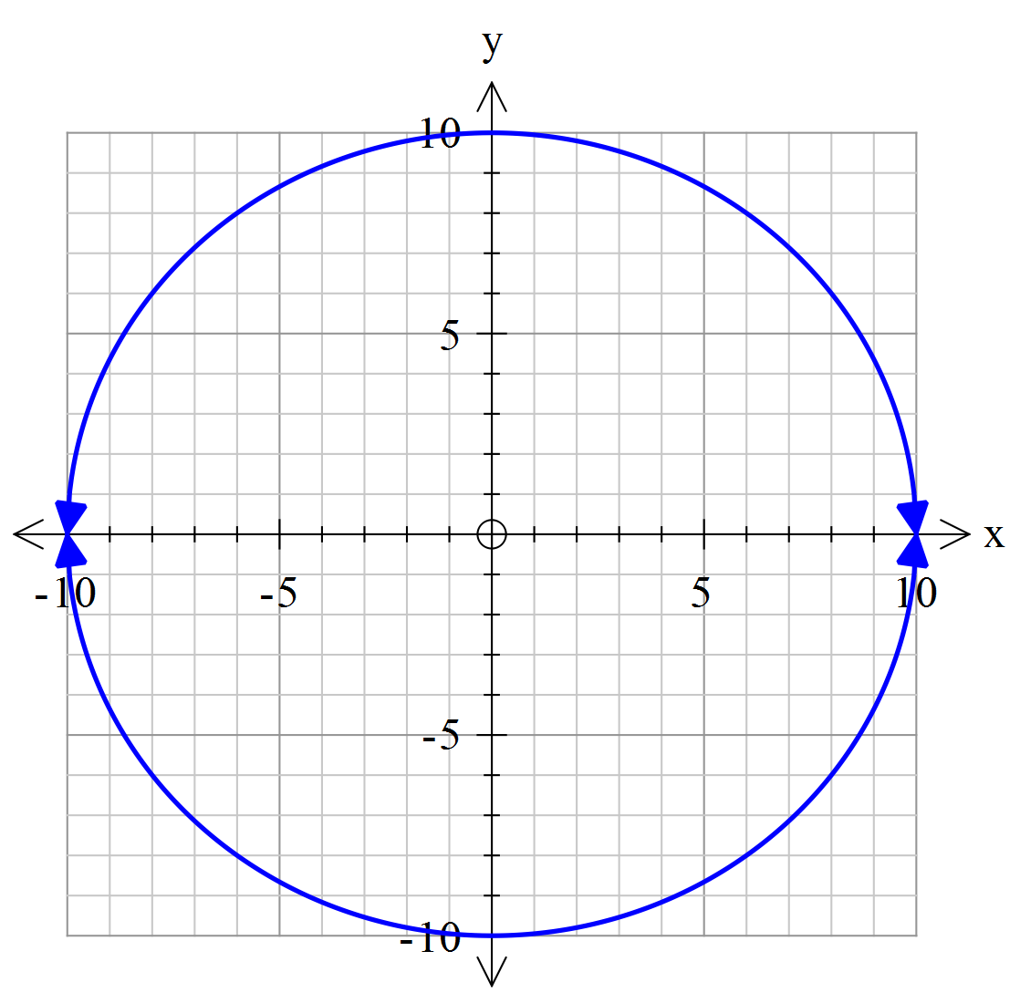
State the equation of each of the relationships.

a)

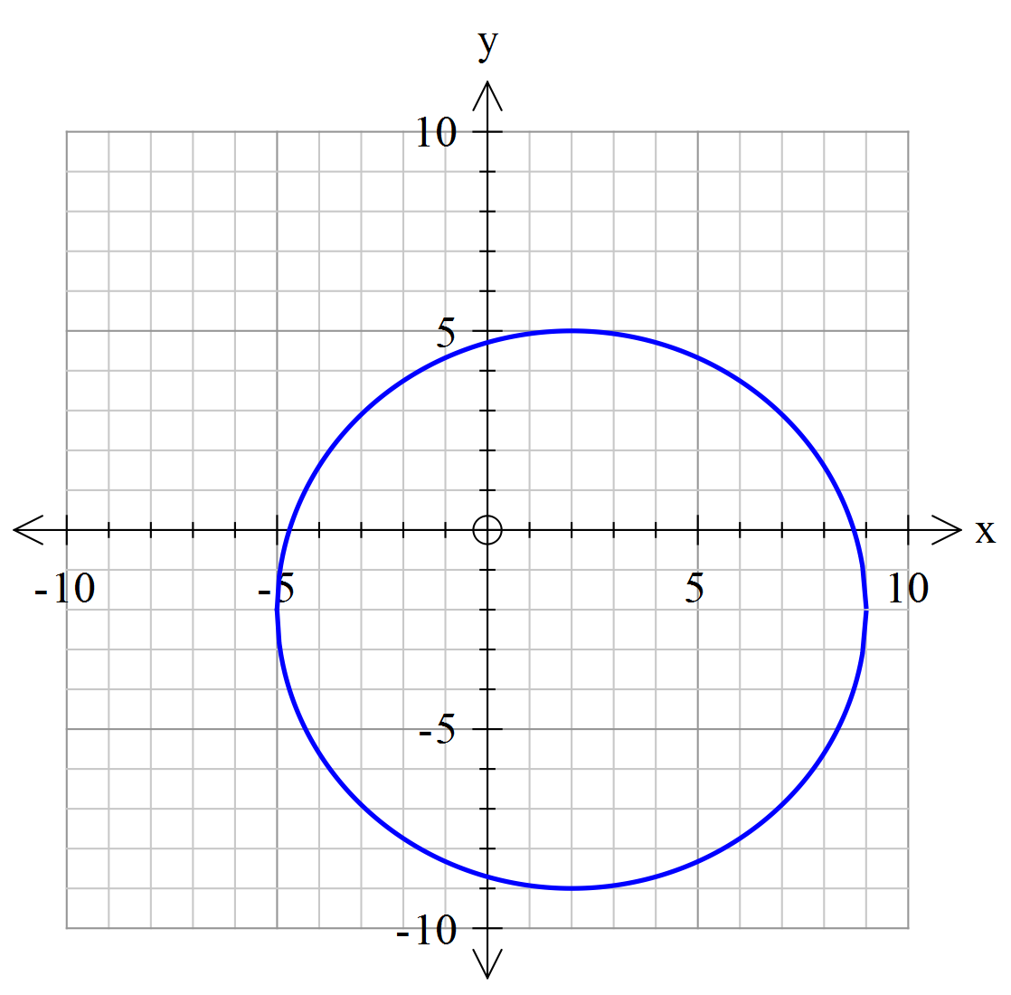

b)

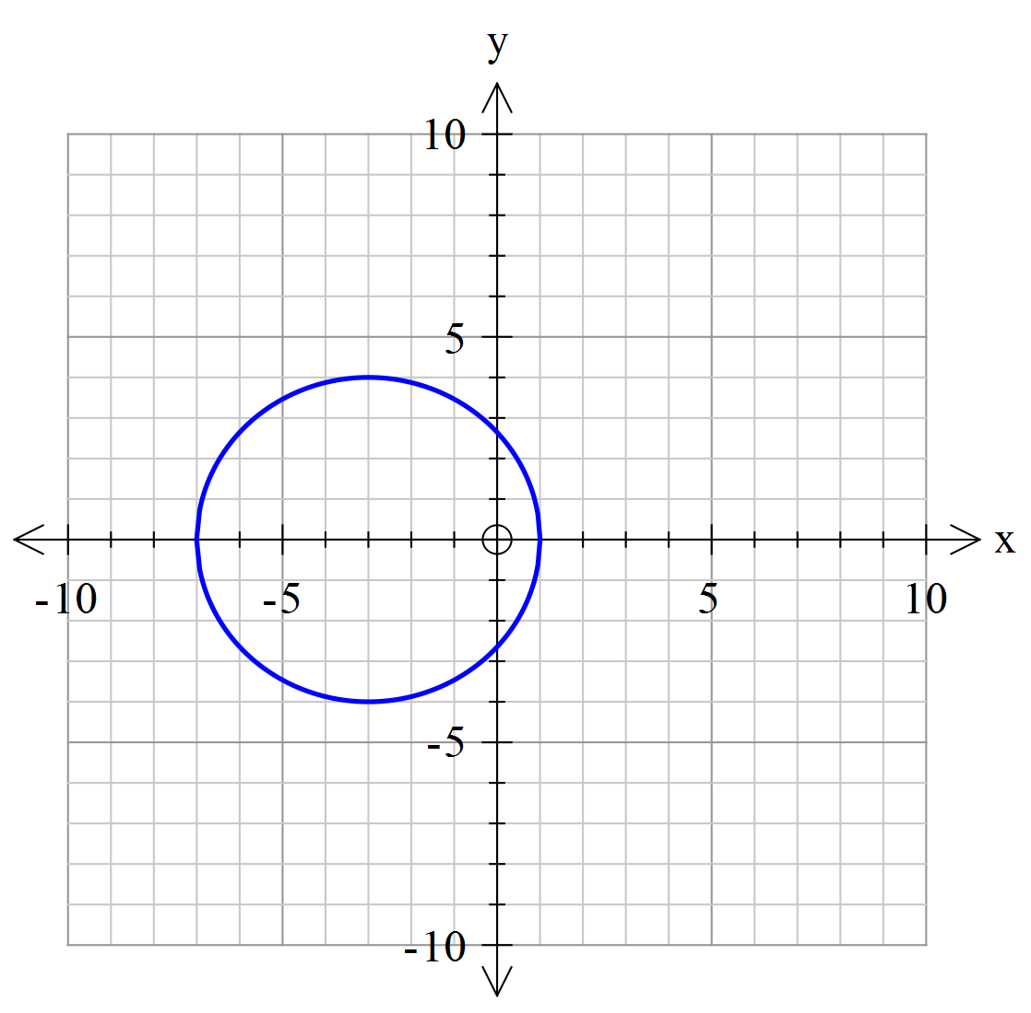

c)

9. (3 marks)

Are the following events complementary? Answer “Complementary” OR “Not Complementary”.

a) Event A: Rolling a number greater than 4 on a die.
Event B: Rolling a number less than 4 on a die.

______________________________

b) Event A: Guessing a Prime number from the set A when A={whole numbers less than 20}
Event B: Guessing a Composite number from a set A when A={whole numbers less than 20}

_____________________________

c) Event A: Picking a vowel from the alphabet.
Event B: Picking a consonant from the alphabet.

_____________________________

10. [2, 2, 4 = 8 marks]

For the circle, 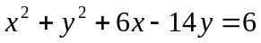 find:

a) the coordinates of the centre

b) the radius

c) the exact coordinates of the intercepts.

11. [6 marks]

Match the given equations to the correct graph.
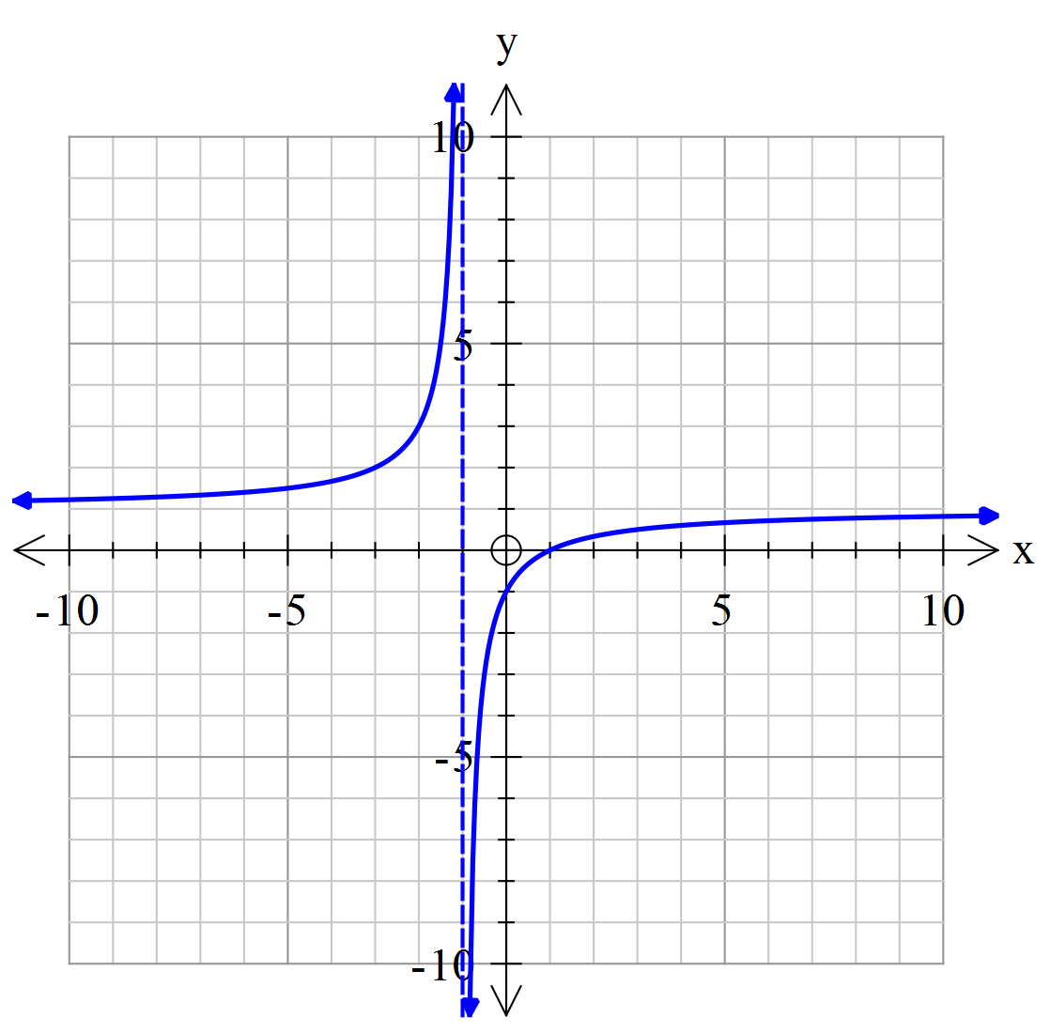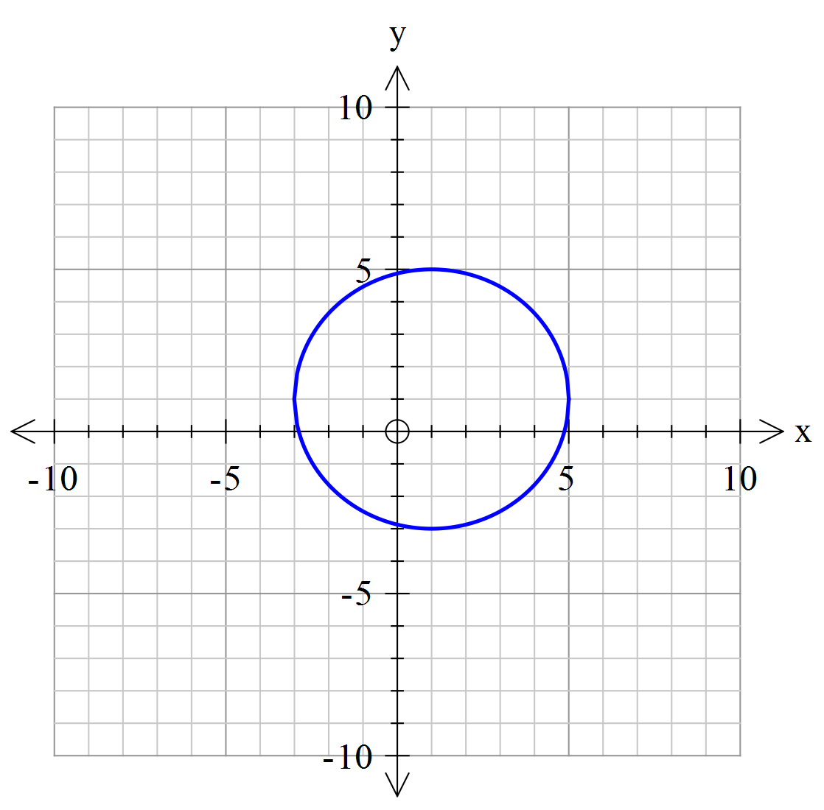

Graph A
Graph B

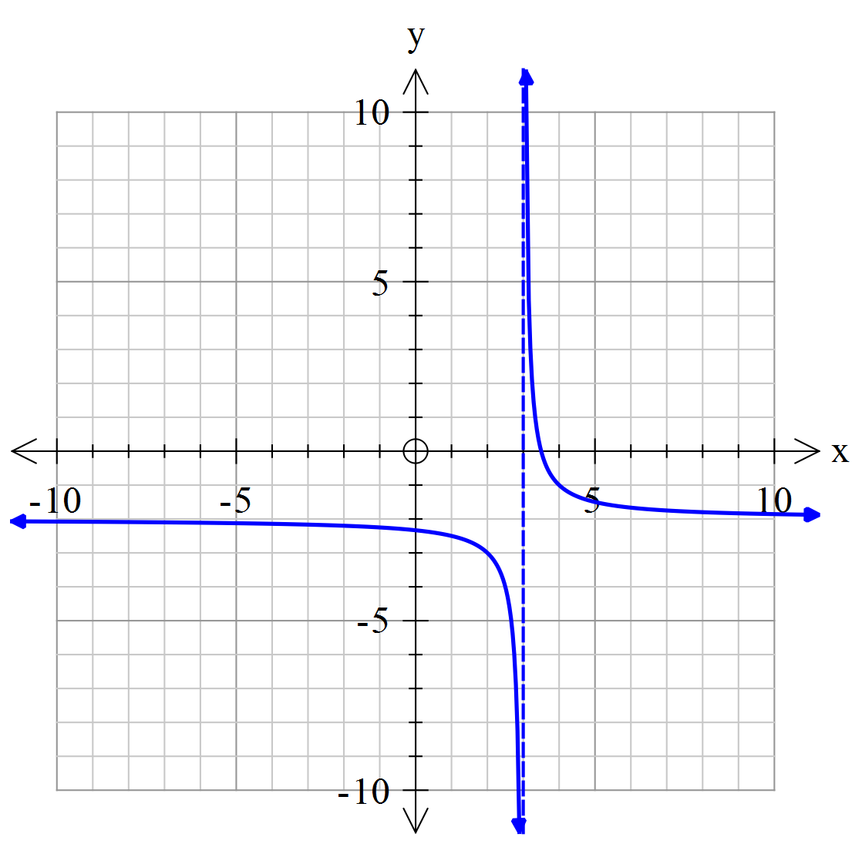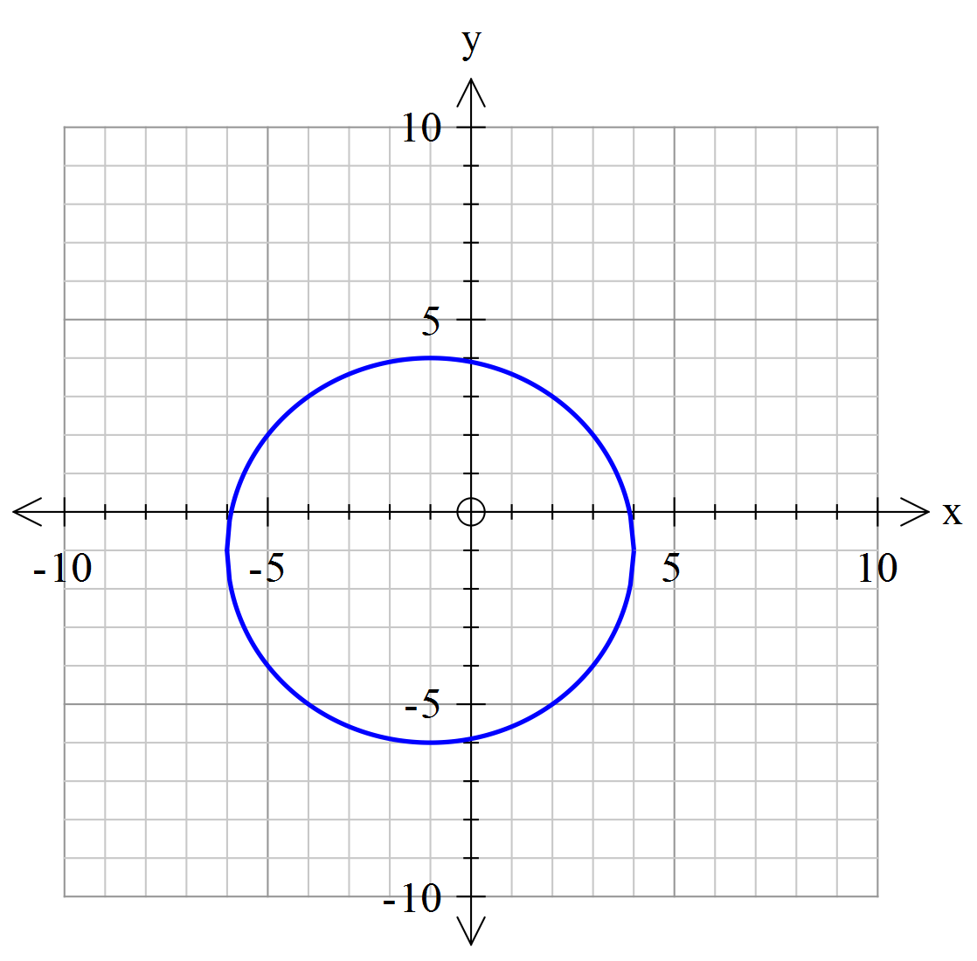

Graph
C
Graph D

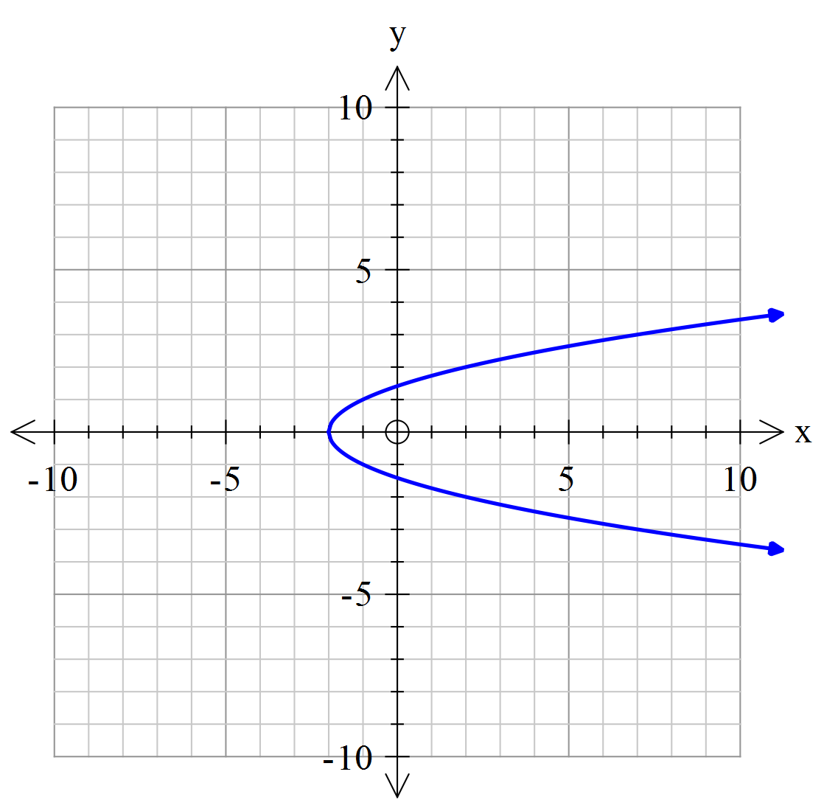
Graph F
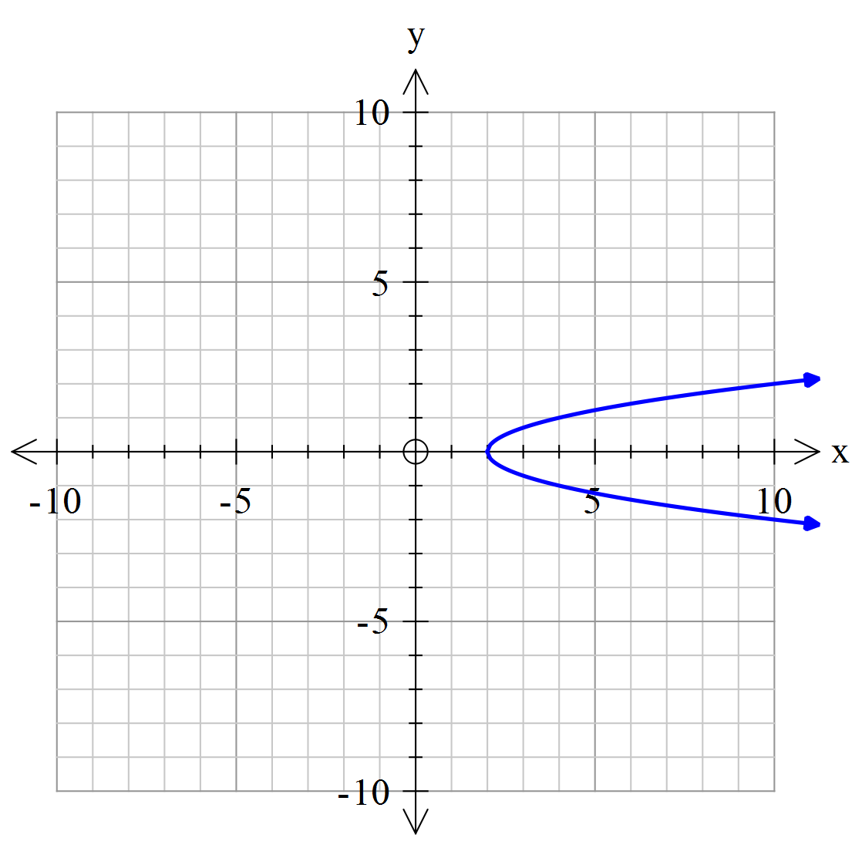
Graph E

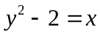 Graph:_________________ 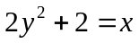 Graph:____________

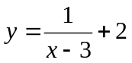 Graph:_____________ 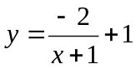 Graph:_________

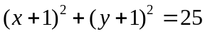Graph:____________ 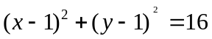 Graph:___________

